1. Basic .NET Framework
(B)What is a IL?
Twist :- What is MSIL or CIL , What is JIT?
(IL)Intermediate Language is also known as MSIL (Microsoft Intermediate Language) or CIL (Common Intermediate Language). All .NET source code is compiled to IL. This IL is then converted to machine code at the point where the software is installed, or at run-time by a Just-In-Time (JIT) compiler.
(B)What is a CLR?
Full form of CLR is Common Language Runtime and it forms the heart of the .NET framework. All Languages have runtime and its the responsibility of the runtime to take care of the code execution of the program. For example VC++ has MSCRT40.DLL,VB6 has MSVBVM60.DLL, Java has Java Virtual Machine etc. Similarly .NET has CLR. Following are the responsibilities of CLR
√ Garbage Collection :- CLR automatically manages memory thus eliminating memory leaks. When objects are not referred GC automatically releases those memories thus providing efficient memory management.
√ Code Access Security :- CAS grants rights to program depending on the security configuration of the machine. Example the program has rights to edit or create a new file but the security configuration of machine does not allow the program to delete a file. CAS will take care that the code runs under the environment of machines security configuration.
√ Code Verification :- This ensures proper code execution and type safety while the code runs. It prevents the source code to perform illegal operation such as accessing invalid memory locations etc.
√ IL( Intermediate language )-to-native translators and optimizer’s :- CLR uses JIT and compiles the IL code to machine code and then executes. CLR also determines depending on platform what is optimized way of running the IL code.
(B)What is a CTS?
In order that two language communicate smoothly CLR has CTS (Common Type System).Example in VB you have “Integer” and in C++ you have “long” these datatypes are not compatible so the interfacing between them is very complicated. In order to able that two different languages can
communicate Microsoft introduced Common Type System. So “Integer” datatype in VB6 and “int” datatype in C++ will convert it to System.int32 which is datatype of CTS. CLS which is covered in the coming question is subset of CTS.
Note: If you have undergone COM programming period interfacing VB6 application with VC++ application was a real pain as the datatype of both languages did not have a common ground where they can come and interface, by having CTS interfacing is smooth.
(B)What is a CLS(Common Language Specification)?
This is a subset of the CTS which all .NET languages are expected to support. It was always a dream of Microsoft to unite all different languages in to one umbrella and CLS is one step towards that. Microsoft has defined CLS which are nothing but guidelines that language to follow so that it can communicate with other .NET languages in a seamless manner.
(B)What is a Managed Code?
Managed code runs inside the environment of CLR i.e. .NET runtime. In short all IL are managed code. But if you are using some third party software example VB6 or VC++ component they are unmanaged code as .NET runtime (CLR) does not have control over the source code execution of the language.
(B)What is a Assembly?
√ Assembly is unit of deployment like EXE or a DLL.
√ An assembly consists of one or more files (dlls, exe’s, html files etc.), and
represents a group of resources, type definitions, and implementations of those types. An assembly may also contain references to other assemblies. These resources, types and references are described in a block of data called a manifest. The manifest is part of the assembly, thus making the assembly self-describing.
√ An assembly is completely self-describing.An assembly contains metadata
information, which is used by the CLR for everything from type checking and security to actually invoking the components methods. As all information is in the
assembly itself, it is independent of registry. This is the basic advantage as compared to COM where the version was stored in registry.
√ Multiple versions can be deployed side by side in different folders. These different versions can execute at the same time without interfering with each other. Assemblies can be private or shared. For private assembly deployment, the assembly is copied to the same directory as the client program that references it. No registration is needed, and no fancy installation program is required.
When the component is removed, no registry cleanup is needed, and no uninstall program is required. Just delete it from the hard drive.
√ In shared assembly deployment, an assembly is installed in the Global Assembly Cache (or GAC). The GAC contains shared assemblies that are globally accessible to all .NET applications on the machine.
(A) What are the different types of Assembly?
There are two types of assembly Private and Public assembly. A private assembly is normally used by a single application, and is stored in the application's directory, or a sub-directory beneath. A shared assembly is normally stored in the global assembly cache, which is a repository of assemblies maintained by the .NET runtime. Shared assemblies are usually libraries of code which many applications will find useful, e.g. Crystal report classes which will be used by all application for Reports.
(B) What is NameSpace?
Namespace has two basic functionality :-√ NameSpace Logically group types, example System.Web.UI logically groups our UI related features.
√ In Object Oriented world many times its possible that programmers will use the
same class name.By qualifying NameSpace with classname this collision is able to be removed.
(B) What is Difference between NameSpace and Assembly?
Following are the differences between namespace and assembly :
√ Assembly is physical grouping of logical units. Namespace logically groups classes.
√ Namespace can span multiple assembly.
(A)If you want to view a Assembly how do you go about it ?
Twist : What is ILDASM ?
When it comes to understanding of internals nothing can beat ILDASM. ILDASM basically converts the whole exe or dll in to IL code. To run ILDASM you have to go to "C:\Program Files\Microsoft
Visual Studio .NET 2003\SDK\v1.1\Bin". Note that i had v1.1 you have to probably change it depending on the type of framework version you have.
If you run IDASM.EXE from the path you will be popped with the IDASM exe program as shown in figure ILDASM. Click on file and browse to the respective directory for the DLL whose assembly you want to view. After you select the DLL you will be popped with a tree view details of the DLL as shown in figure ILDASM. On double clicking on manifest you will be able to view details of assembly, internal IL code etc as shown in Figure Manifest View.
Note : The version number are in the manifest itself which is defined with the DLL or EXE thus making deployment much easier as compared to COM where the information was stored in registry. Note the version information in Figure Manifest view.
You can expand the tree for detail information regarding the DLL like methods etc.
Figure:- 1.1 ILDASM
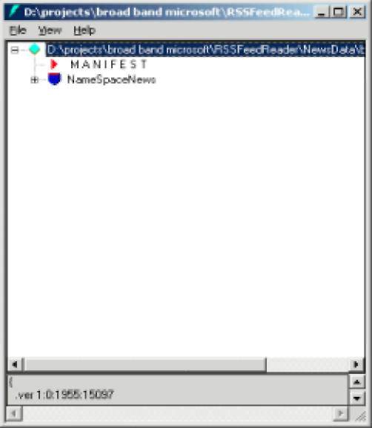
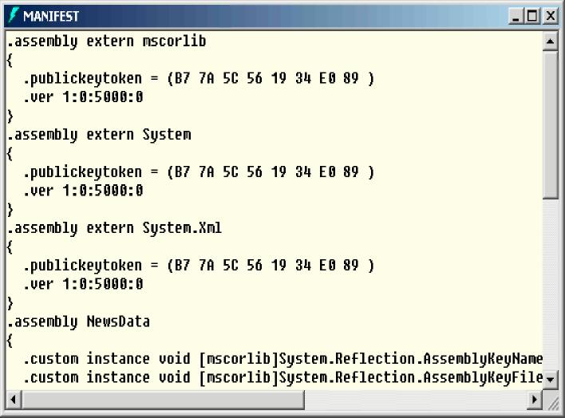
Figure :- 1.2 Manifest View
(A) What is Manifest?
Assembly metadata is stored in Manifest. Manifest contains all the metadata needed to do the following things (See Figure Manifest View for more details):
√ Version of assembly
√ Security identity
√ Scope of the assembly
√ Resolve references to resources and classes.
√ The assembly manifest can be stored in either a PE file (an .exe or .dll) with Microsoft intermediate language (MSIL) code or in a stand-alone PE file that contains only assembly manifest information.

(B)Where is version information stored of an assembly ?
Version information is stored in assembly in manifest.
(I)Is versioning applicable to private assemblies?
Versioning concept is only applicable to global assembly cache (GAC) as private assembly lie in their individual folders.
(B) What is GAC ?
Twist :- What are situations when you register .NET assembly in GAC ?
GAC (Global Assembly Cache) is used where shared .NET assembly reside. GAC is used in the following situations :-√ If the application has to be shared among several application.
√ If the assembly has some special security requirements like only administrators can remove the assembly. If the assembly is private then a simple delete of assembly the assembly file will remove the assembly.
Note :- Registering .NET assembly in GAC can lead to the old problem of DLL hell, where COM version was stored in central registry. So GAC should be used when absolutely necessary.
(I) What is the concept of strong names ?
Twist :- How do we generate strong names or what is the process of generating strong names, What is use the of SN.EXE , How do we apply strong names to assembly, How do you sign an assembly?
Strong name is similar to GUID(It is supposed to be unique in space and time) in COM components.Strong Name is only needed when we need to deploy assembly in GAC. Strong Names helps GAC to differentiate between two versions. Strong names use public key cryptography (PKC) to ensure that no one can spoof it.PKC use public key and private key concept.
Following are the step to generate a strong name and sign a assembly :-
√ Go to “Visual Studio Command Prompt”. See below figure “Visual studio Command Prompt”. Note the samples are compiled in 2005 but 2003 users do not have to worry about it. Same type of command prompt will be seen in 2003 also.
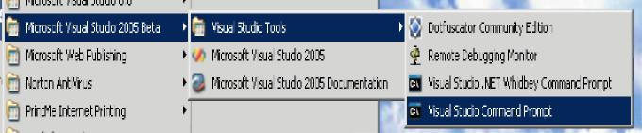
Figure :- 1.3 Visual Studio Command Prompt
√ After you are in command prompt type sn.exe -k “c:\test.snk”.

' Visual Studio Command Prompt
Setting environment for using Microsoft Uisual Studio 2005 tools.
(If you have another version of Uisual Studio or Uisual C++ installed and wish
to use its tools from the command line, run vsvars32.bat for that version.)
C:\Program FilesSCommon Files\System\Mapi\1033>sn.exe -k ^c:\test.snk"

' Visual Studio Command Prompt
(If you have another version of Uisual Studio or Uisual C++ installed and wish
to use its tools from the command line, run vsvars32.bat for that version.) '—
C:\Program Files\Common Files\System\Mapi\1033>sn.exe -k "c:\test.snk"
Microsoft <R) .NET Framework Stro
ng Name Utility Uersion 2.0.40607.16 Copyright (C) Microsoft Corporation, fill rights reserved.
Key pair written to c:\test.snk
C:\Program Files\Common Files\System\Mapi\1033>
Figure :- 1.4 Running SN.EXE

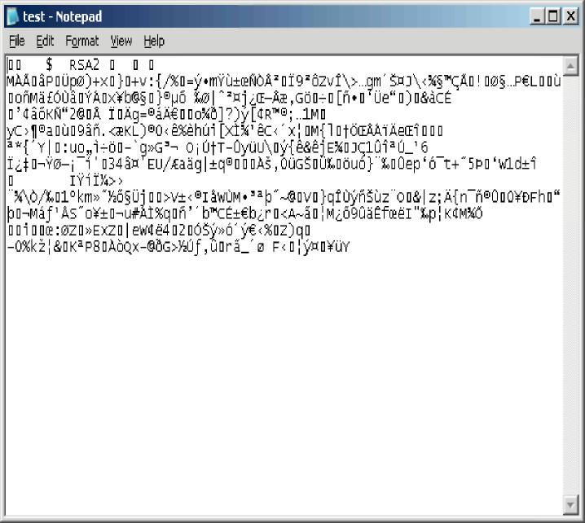
Figure :- 1.6 Sample view of test.snk file
√ After generation of the file you can view the SNK file in a simple notepad. √ After the SNK file is generated its time to sign the project with this SNK file.
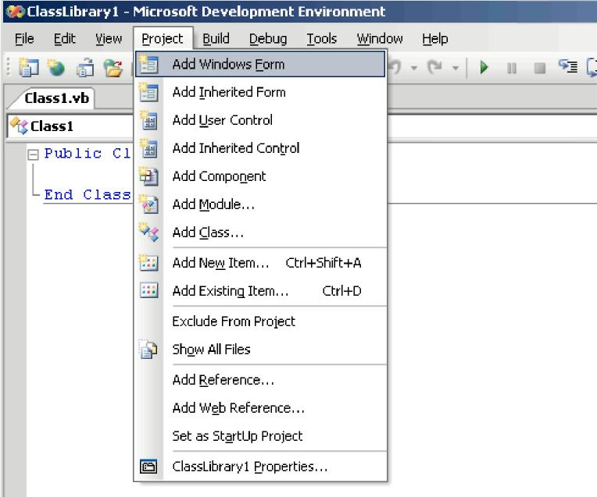
Figure:- 1.7 Click on project and then click on “classlibrary1 properties” menu to sign the assembly
√ Click on project -- properties and the browse the SNK file to the respective folder and compile the project.
Figure :- 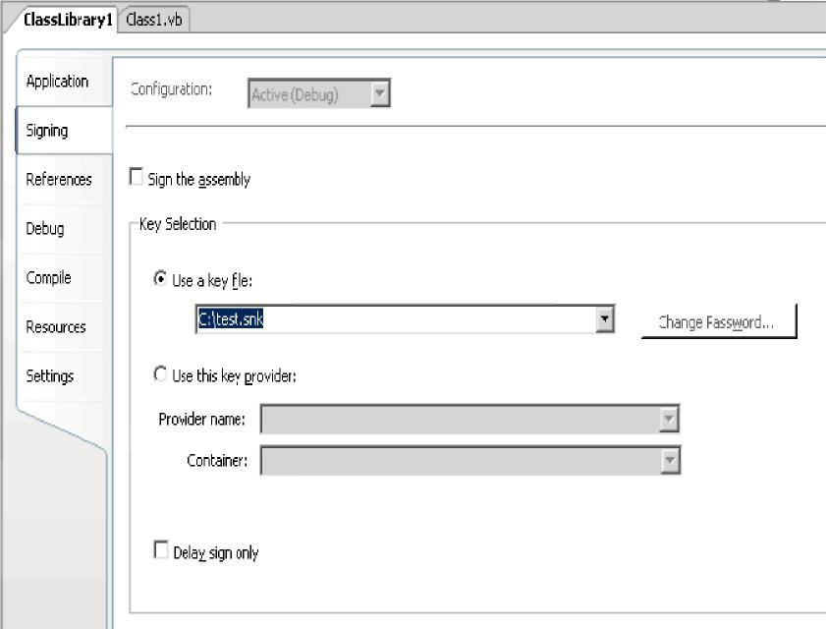 1.8 Click on Use a key file to sign the assembly with strong name
(I)How to add and remove an assembly from GAC?
There are two ways to install .NET assembly in GAC:-√ Using Microsoft Installer Package. You can get download of installer from http://www.microsoft.com.
√ Using Gacutil. Goto “Visual Studio Command Prompt” and type “gacutil –i (assembly_name)”, where (assembly_name) is the DLL name of the project.
(B) What is Delay signing ?
During development process you will need strong name keys to be exposed to developer which is not a good practice from security aspect point of view.In such situations you can assign the key later on and during development you an use delay signing
Following is process to delay sign an assembly:
√ First obtain your string name keys using SN.EXE.
√ Annotate the source code for the assembly with two custom attributes from System.Reflection: AssemblyKeyFileAttribute, which passes the name of the file containing the public key as a parameter to its constructor. AssemblyDelaySignAttribute, which indicates that delay signing, is being used by passing true as a parameter to its constructor. For example as shown below:
[Visual Basic]
<Assembly:AssemblyKeyFileAttribute("myKey.snk")>
<Assembly:AssemblyDelaySignAttribute(true)> [C#]
[assembly:AssemblyKeyFileAttribute("myKey.snk")]
[assembly:AssemblyDelaySignAttribute(true)]
The compiler inserts the public key into the assembly manifest and reserves space in the PE file for the full strong name signature. The real public key must be stored while the assembly is built so that other assemblies that reference this assembly can obtain the key to store in their own assembly reference.
√ Because the assembly does not have a valid strong name signature, the verification of that signature must be turned off. You can do this by using the –Vr option with the Strong Name tool.The following example turns off verification for an assembly called myAssembly.dll.
Sn –Vr myAssembly.dll
√ Just before shipping, you submit the assembly to your organization's signing authority
for the actual strong name signing using the –R option with the Strong Name tool.
The following example signs an assembly called myAssembly.dll with a strong name
using the sgKey.snk key pair.
Sn -R myAssembly.dll sgKey.snk
(B)What is garbage collection?
Garbage collection is a CLR feature which automatically manages memory. Programmers forget
to release the objects while coding Laziness (Remember in VB6 where one of the good
practices is to set object to nothing). CLR automatically releases objects when they are no longer in use and refernced. CLR runs on non-deterministic to see the unused objects and cleans them. One side effect of this non-deterministic feature is that we cannot assume an object is destroyed when it goes out of the scope of a function. Therefore, we should not put code into a class destructor to release resources.
(I) Can we force garbage collector to run ?
System.GC.Collect() forces garbage collector to run. This is not recommended but can be used if situations arises.
(B)What is reflection?
All .NET assemblies have metadata information stored about the types defined in modules. This metadata information can be accessed by mechanism called as “Reflection”.System. Reflection can be used to browse through the metadata information.
Using reflection you can also dynamically invoke methods using System.Type.Invokemember. Below is sample source code if needed you can also get this code from CD provided, go to “Source code” folder in “Reflection Sample” folder.
Public Class Form1
Private Sub Form1_Load(ByVal sender As System.Object, ByVal e As System.EventArgs) Handles MyBase.Load Dim Pobjtype As Type Dim PobjObject As Object
Dim PobjButtons As New Windows.Forms.Button() Pobjtype = PobjButtons.GetType() For Each PobjObject In Pobjtype.GetMembers
LstDisplay.Items.Add(PobjObject.ToString()) Next End Sub End Class
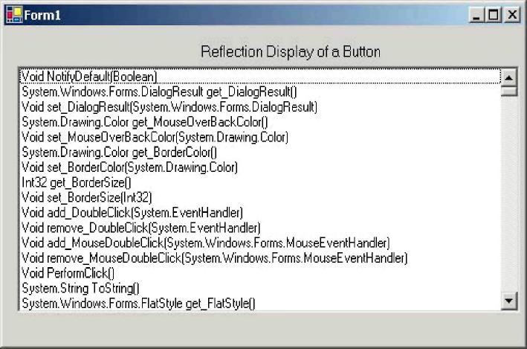
Note :- Sample source code are compiled using VB.NET 2005.
Figure:- 1.9 Sample reflection display
Sample source code uses reflection to browse through “Button” class of “Windows.Forms”. If you compile and run the program following is output as shown in “Sample Reflection Display”. Using reflection you can also dynamically invoke a method using “System.Type.InvokeMember”.
Note :- System.Type.InvokeMember is left as homework for readers. Believe me you will enjoy doing it yourself and the concept of reflection will be clearer.
(P)What are different types of JIT ?
Note :- This question can only be asked when the interviewer does not know what he wants. It was asked to me in one of interview and for 15 minutes he was roaming around the same question in order to get answer from me (requirement was for a simple database project). Beware of such companies and interviewers you can land up no where.
JIT compiler is a part of the runtime execution environment.
In Microsoft .NET there are three types of JIT compilers:
√ Pre-JIT :- Pre-JIT compiles complete source code into native code in a single compilation cycle. This is done at the time of deployment of the application.
√ Econo-JIT :- Econo-JIT compiles only those methods that are called at runtime. However, these compiled methods are removed when they are not required.
√ Normal-JIT :- Normal-JIT compiles only those methods that are called at runtime. These methods are compiled the first time they are called, and then they are stored in cache. When the same methods are called again, the compiled code from cache is used for execution.
(B) What are Value types and Reference types ?
Value types directly contain their data which are either allocated on the stack or allocated in-line in a structure.
Reference types store a reference to the value's memory address, and are allocated on the heap. Reference types can be self-describing types, pointer types, or interface types.
Variables that are value types each have their own copy of the data, and therefore operations on one variable do not affect other variables. Variables that are reference types can refer to the same object; therefore, operations on one variable can affect the same object referred to by another variable. All types derive from the System.Object base type.
(B) What is concept of Boxing and Unboxing ?
Boxing permits any value type to be implicitly converted to type object or to any interface type implemented by value type. Boxing is a process in which object instances are created and copy values in to that instance.
Unboxing is vice versa of boxing operation where the value is copied from the instance in to appropriate storage location.
Below is sample code of boxing and unboxing where integer data type is converted in to object and then vice versa.
Dim x As Integer
Dim y As Object
x = 10
‘ boxing process
y = x
‘ unboxing process x = y
(B) What is the difference between VB.NET and C# ?
Well this is the most debatable issue in .NET community and people treat there languages like religion. Its a subjective matter which language is best. Some like VB.NET’s natural style and some like professional and terse C# syntaxes. Both use the same framework and speed is also very much equivalents. But still let’s list down some major differences between them :-Advantages VB.NET :-√ Has support for optional parameters which makes COM interoperability much easy.
√ With Option Strict off late binding is supported.Legacy VB functionalities can be used by using Microsoft.VisualBasic namespace.
√ Has the WITH construct which is not in C#.
√ The VB.NET part of Visual Studio .NET compiles your code in the background. While this is considered an advantage for small projects, people creating very large projects have found that the IDE slows down considerably as the project gets larger.
Advantages of C#
√ XML documentation is generated from source code but this is now been incorporated in Whidbey.
√ Operator overloading which is not in current VB.NET but is been introduced in Whidbey.
√ Use of this statement makes unmanaged resource disposal simple.
√ Access to Unsafe code. This allows pointer arithmetic etc, and can improve
performance in some situations. However, it is not to be used lightly, as a lot of the normal safety of C# is lost (as the name implies).This is the major difference that you can access unmanaged code in C# and not in VB.NET.
* How much ever this book tries it can not match the huge variations of questions that have been asked in.NET interviews.But note there will be variations and they will map to some question of this book.
(I)What is the difference between System exceptions and Application exceptions?
All exception derives from Exception Base class. Exceptions can be generated programmatically or can be generated by system. Application Exception serves as the base class for all application-specific exception classes. It derives from Exception but does not provide any extended functionality. You should derive your custom application exceptions from Application Exception.
Application exception is used when we want to define user defined exception, while system exception is all which is defined by .NET.
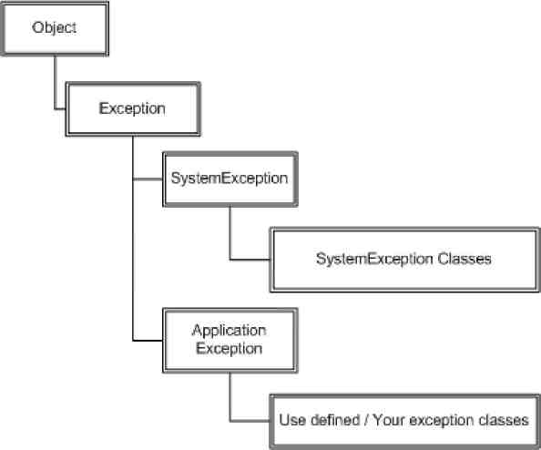
Figure :- 1.10 Exception Hierarchy
Note:- Frankly I have always relied on using Microsoft exception application blocks. As such I have never used application exception; I think most of the work is done using System exception classes.
(I)What is CODE Access security?
CAS is part of .NET security model that determines whether or not a piece of code is allowed to run and what resources it can use while running. Example CAS will allow an application to read but not to write and delete a file or a resource from a folder..
(I)What is a satellite assembly?
Refer Localization chapter for more details
(A)How to prevent my .NET DLL to be decompiled?
By design .NET embeds rich Meta data inside the executable code using MSIL. Any one can easily decompile your DLL back using tools like ILDASM (owned by Microsoft) or Reflector for .NET which is a third party. Secondly there are many third party tools which make this decompiling process a click away. So any one can easily look in to your assemblies and reverse engineer them back in to actual source code and understand some real good logic which can make it easy to crack your application.
The process by which you can stop this reverse engineering is using “obfuscation”. It’s a technique which will foil the decompilers. There are many third parties (XenoCode, Demeanor for .NET) which provide .NET obfuscation solution. Microsoft includes one that is Dotfuscator Community Edition with Visual Studio.NET.
Note: - I leave this as homework to reader’s compile, a DLL obfuscate it using “Dotfuscator Community Edition” which comes with Visual Studio.NET and try viewing the same using ILDASM.
(I) What is the difference between Convert.toString and .toString() method ?
Just to give an understanding of what the above question means seethe below code.
int i =0;
MessageBox.Show(i.ToString());
MessageBox.Show(Convert.ToString(i));
We can convert the integer “i” using “i.ToString()” or “Convert.ToString” so what’s the difference. The basic difference between them is “Convert” function handles NULLS while “i.ToString()” does not it will throw a NULL reference exception error. So as good coding practice using “convert” is always safe.
(A) What is Native Image Generator (Ngen.exe)?
The Native Image Generator utility (Ngen.exe) allows you to run the JIT compiler on your assembly's MSIL and generate native machine code which is cached to disk. After the image is created .NET runtime will use the image to run the code rather than from the hard disk. Running Ngen.exe on an assembly potentially allows the assembly to load and execute faster, because it restores code and data structures from the native image cache rather than generating them dynamically.
Below are some points to be remembered for Native Image Generator:-√ Native images load faster than MSIL because JIT compilation and type-safety verification is eliminated.
√ If you are sharing code between process Ngen.exe improves the performance
significantly. As Native image generated Windows PE file so a single DLL file can be shared across applications. By contrast JIT produced code are private to an assembly and can not be shared.
√ Native images enable code sharing between processes.
√ Native images require more storage space and more time to generate.
√ Startup time performance improves lot. We can get considerable gains when applications share component assemblies because after the first application has been started the shared components are already loaded for subsequent applications. If assemblies in an application must be loaded from the hard disk, does not benefit as much from native images because the hard disk access time shadows everything.
√ Assemblies in GAC do not benefit from Native image generator as the loader performs extra validation on the strong named assemblies thus shadowing the benefits of Native Image Generator.
√ If any of the assemblies change then Native image should also be updated.
√ You should have administrative privilege for running Ngen.exe.
√ While this can fasten your application startup times as the code is statically compiled but it can be somewhat slower than the code generated dynamically by the JIT compiler. So you need to compare how the whole application performance with Ngen.exe and with out it.
To run Ngen.exe, use the following command line.
ngen.exe install <assemblyname>
This will synchronously precompile the specified assembly and all of its dependencies. The generated native images are stored in the native image cache.
In .NET Framework 2.0 there is a service (.NET Runtime Optimization Service) which can precompile managed assemblies in the background. You can schedule your assemblies to be precompiled asynchronously by queueing them up with the NGEN Service. Use the following command line.
ngen.exe install <assemblyname> /queue:<priority>
Assemblies which are critical to your application's start up time should either be precompiled synchronously or asynchronously with priority 1. Priority 1 and 2 assemblies are precompiled aggressively while Priority 3 assemblies are only precompiled during machine idle-time. Synchronously precompiling your critical assemblies guarantees that the native images will be available prior to the first time your end user launches the application but increases the time taken to run your application's set up program.
You can uninstall an assembly and its dependencies (if no other assemblies are dependent on them) from the native image cache by running the following command.
ngen.exe uninstall <assemblyname>
Native images created using Ngen.exe cannot be deployed; instead they need to be created on the end user's machine. These commands therefore need to be issued as part of the application's setup program. Visual Studio .NET can be used to implement this behavior by defining custom actions in a Microsoft Installer (MSI) package.
Note: - One of the things the interviewer will expect to be answered is what scenario will use a Native Image generator. Best is to say that we first need to test the application performance with Native Image and with out it and then make a decision.
(A) We have two version of the same assembly in GAC? I want my client to make choice of which assembly to choose?
Note: - I really want to explain this in depth for two reasons. First I have seen this question been frequently asked and second it’s of real practical importance. I have faced this in every of my .NET projects...So let’s try to get this fundamental not in our brain but in our heart.
OK first let’s try to understand what the interviewer is talking about. Let’s say you have made an application and its using a DLL which is present in GAC. Now for some reason you make second version of the same DLL and put it in GAC. Now which DLL does the application refer? Ok by default it always refers the latest one. But you want that it should actually use the older version.

So first we answer in short. You need to specify “bindingRedirect” in your config file. For instance in the below case “ClassLibraryVersion” has two versions “1.1.1830.10493” and “1.0.1830.10461” from which “1.1.1830.10493” is the recent version. But using the bindingRedirect we can specify saying “1.0.1830.10461” is the new version. So the client will not use “1.1.1830.10493”.
<configuration>
<runtime>
<assemblyBinding xmlns="urn:schemas-microsoft-com:asm.v1">
<dependentAssembly>
<assemblyIdentity name="ClassLibraryVersion"
publicKeyToken="b035c4774706cc72"
culture="neutral"/>
<bindingRedirect oldVersion= "1.1.1830.10493"
newVersion= "1.0.1830.10461"/>
</dependentAssembly>
</assemblyBinding>
</runtime>
</configuration>
Ok now I will try to answer it in long way by doing a small sample project. Again this project will be done using C#. So in CD you can find the “Versioning” project. Below is the solution display, it has two projects one the windows client project ( “WindowsVersioningCSharp” ) and second the class library project ( “ClassLibraryVersion” ) which will be installed in GAC with two versions.
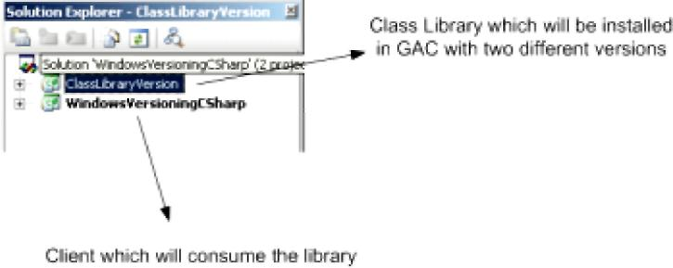
Figure 1.11: - Solution files for the versioning project.
Our first primary goal is to put two different versions of the same DLL in GAC. So let’s make a walk through of “ClassLibraryVersion” project. It’s a very simple class which has “Version” function which just sends a string “This is old Version”. Second we will also just ensure that the assembly version is “1.0” in the “AssemblyInfo.cs”.
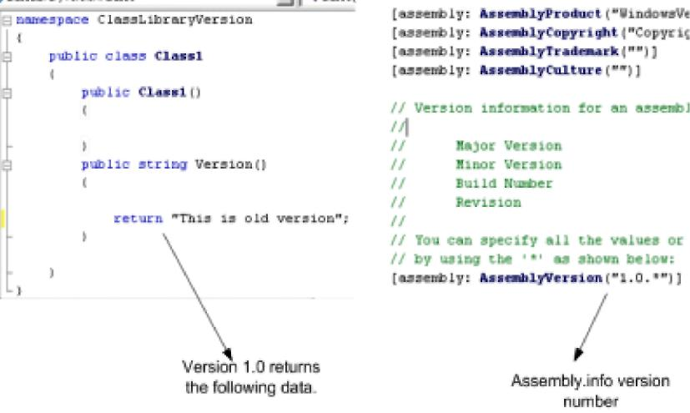
Figure 1.12 : - Assembly Version 1.0
Second in order that we can put a DLL in GAC we need to create generate strong names and assign the same to the class. For instance, in below figure I have generated the strong name in “mykey.snk” and assigned the same to the DLL.
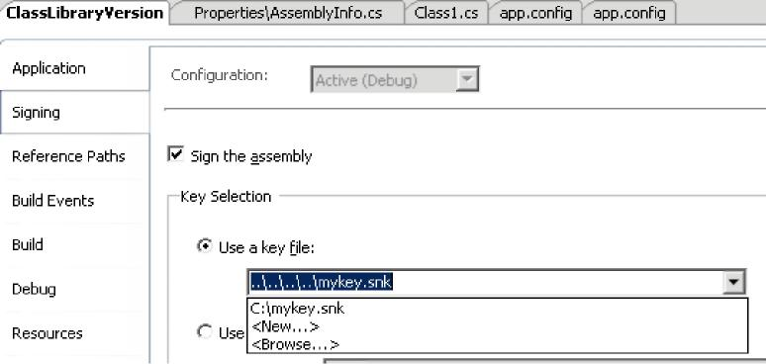
Figure 1.13 : - Strong naming your DLL
Finally we need to install the same in GAC using “gacutil” tool. Below is the figure which shows the same. This installs one version of “ClassLibraryVersion.dll” in GAC.
~ Visual Studio Command Prompt
l:\Documents and Setting's\fidninistrator>gacutil -i "C:\SourceCode\Uers 'owsUersioninffCSliarpSClassLibraryUersionSbinSDehugSClassLibraryUersior dcrosoft (R> .NET Global Assembly Cache Utility. Uersion 2.0.40607." Jopyriglit CO Microsoft Corporation, fill rights reserved.
Figure 1.14 : - Install the same in GAC
Now it is time to create a second version of the DLL. So here is what we will do first we will just return a different string value for this new version DLL. You can see in the below figure I have changed the string to return “This is New Version”. Secondly we also need to change the AssemblyVersion to “1.1.*” in the “AssemblyInfo.cs” file. After that again compile the DLL and run the “gacutil” to register this second version of the “ClasLibraryVersion.dll”.
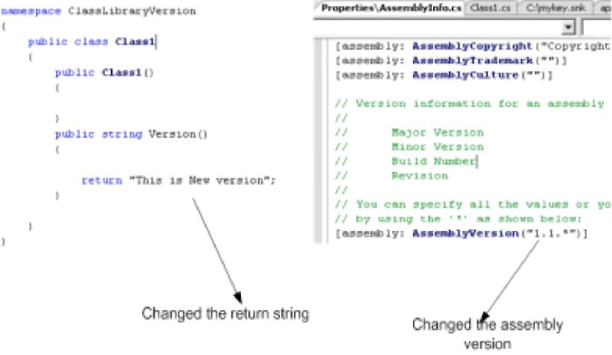
Figure 1.15 : - Rename to Assembly Version 1.1
Now when we view the GAC we can see two version of “ClassLibraryVersion” i.e. “1.1.1832.2619” and “1.0.1832.2172” (see figure below).
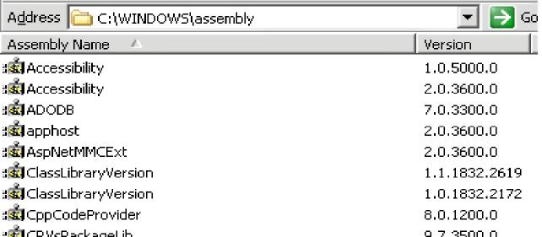
Figure 1.16 : - Two version of “ClassLibraryVersion” dll.
Now that we have created the environment of two version of the same DLL in GAC its time to look at how client can make a choice between those versions. We need to generate “publicKeyToken” in order to move ahead. Below is a sample print screen which shows how we can use “sn.exe” to generated the public key token. Note the “-T” parameter.
s and Settings\Administrator>sn —T "C:\SourceCode\Uersioning\Uin harpNClassLibraryUers ion\bin\Debug\ClassLibraryUers ion.dll"
R> .NET Framework Strong Name Utility Uersion 2.0.40607.16 C> Microsoft Corporation, fill rights reserved.
token is bB35c4774706cc72
Figure 1.17 : - Get the PublicKeyToken
Now let’s look at the client which will consume this DLL. I have just added windows form and a button to the same. In the button click we will try to call the version function and display the data. So below is the code in the first step we create the object of “ClassLibraryVersion.Class1” and in the second step we call the “Version” function to display the data.
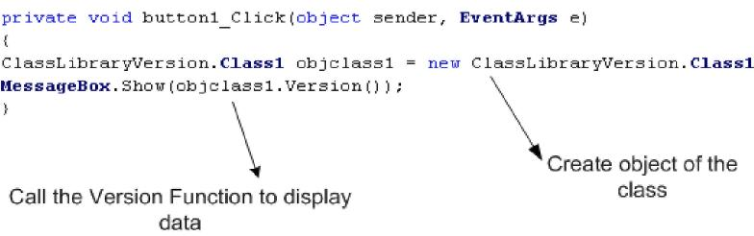
Figure 1.18 : - Client code calling the GAC class.
Now comes the most important part of the whole thing the “app.config” file which will decide which version should be used. So add a new “app.config” file in the project and add the “AssemblyBinding” section as show below. So you need to specify the following things:-√ Assembly name in the “name” attribute of “assemblyIdentity” section.
√ Specify the “publicKeyToken” value in the “assemblyIndentity” section which was generated using “sn.exe –T ‘dllname.dll’ “.
√ Specify the “oldVersion” and “newVersion” values in the “bindingRedirect” element. So what ever version we want the client to use should be specified in the “newVersion” attribute.
You can see from the figure below I have specified that client should use “1.0.*” version. So the client will display “This is old Version”.
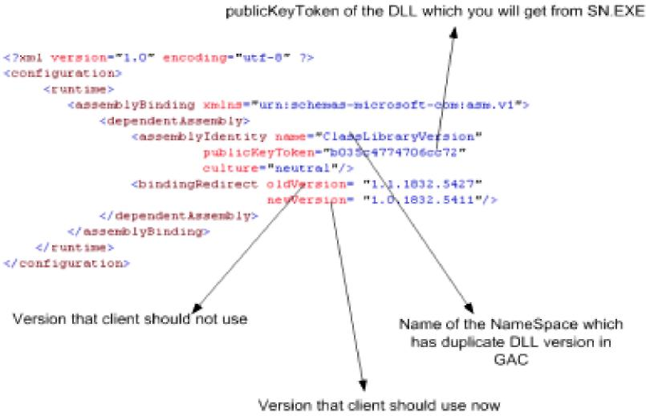
Figure 1.19 : - App.config file using the BindingRedirect
If you run the source code with changing version numbers you can see the below two message boxes on different version numbers. That is “This is old version” will be displayed when “newVersion” value is “1.0.1832.5411” and “This is new Version” will be displayed when “newVersion” value is “1.1.1832.5427”.
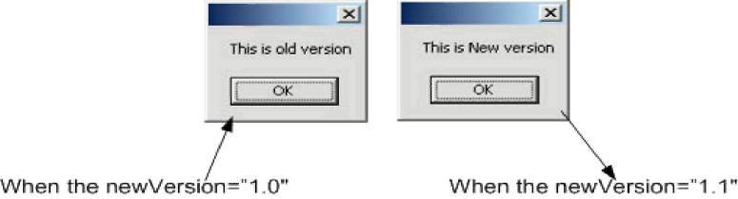
Figure 1.20 : - Different Display depending on version numbers
Note: - Source code is provided in “versioning” folder. But as you compile the DLL’s different publicToken numbers are created so you need to run the sn.exe in your machine and change the token number accordingly in the “App.config” file.
(A)What is CodeDom?
“CodeDom” is an object model which represents actually a source code. It is designed to be language independent - once you create a “CodeDom” hierarchy for a program we can then generate the source code in any .NET compliant language. So let’s try to do something real practical and simple to just get a feel of how powerful “CodeDom” is.
Note :- You can get the source code in CD in “CodeDom” folder.
We will try to generate the following code below. The below code which will be generated does not do anything special buy just displays a hello message and waits for the key to be pressed.
namespace InterviewQuestions
{
using System;
public class EntryPoint
{
public static void Main()
{
System.Console.WriteLine(“Hello from Interview Question series”);
System.Console.ReadLine();
}
}
}
The “Codedom” folder in the CD has one “GenerateCode” method which returns “CodeCompileUnit” object. “CodeDom” is nothing but a full DOM model where every object in the structure represents a code unit. I have put comments the code so that the code is self understandable. I have commented the code below so that readers can follow what is exactly happening. When you click the button it generates the “MyCode.cs” and also compiles the “Mycode.exe” in the “bin” folder.
private CodeCompileUnit GenerateCode()
{
// Definition of the Main method which will be entry point
CodeEntryPointMethod objMainMethod = new CodeEntryPointMethod();
objMainMethod.Name = “Main”;
// generate this expression: Console
CodeTypeReferenceExpression consoleType = new CodeTypeReferenceExpression();
consoleType.Type = new CodeTypeReference(typeof(Console));
// Set up the argument list to pass to Console.WriteLine()
CodeExpression[] writeLineArgs = new CodeExpression[1];
CodePrimitiveExpression arg0 = new CodePrimitiveExpression(“Hello from Interview Question series”);
writeLineArgs[0] = arg0;
// generate this statement: Console.WriteLine(message)
CodeMethodReferenceExpression writeLineRef = new CodeMethodReferenceExpression(consoleType, “WriteLine”);
CodeMethodInvokeExpression writeLine = new CodeMethodInvokeExpression(writeLineRef, writeLineArgs);
// generate this statement: Console.ReadLine()
CodeMethodReferenceExpression readLineRef = new CodeMethodReferenceExpression(consoleType, “ReadLine”);
CodeMethodInvokeExpression readLine = new CodeMethodInvokeExpression(readLineRef);
// Add Main() method to a class
CodeTypeDeclaration theClass = new CodeTypeDeclaration();
theClass.Members.Add(objMainMethod);
theClass.Name = “EntryPoint”;
// Add both the code of WriteLine and Readline
objMainMethod.Statements.Add(writeLine);
objMainMethod.Statements.Add(readLine);
// Add namespace and add class
CodeNamespace ns = new CodeNamespace(“InterviewQuestions”);
ns.Imports.Add(new CodeNamespaceImport(“System”));
ns.Types.Add(theClass);
// Generate the Compile Unit
CodeCompileUnit unit = new CodeCompileUnit();
unit.Namespaces.Add(ns);
Sample provided is very basic but in actual project using codedom can be very complicated. Projects where you need auto code generation codedom can be a right choice. Beware of high bulky architecture created due to codedom.

2..NET Interoperability
(I) How can we use COM Components in .NET?
Twist : What is RCW ?
.NET components communicate with COM using RCW (Runtime Callable Wrapper). Following are the ways with which you can generate RCW :-√ Adding reference in Visual Studio.net. See figure below (Adding reference using VS.NET 2005). Wrapper class is generated and placed in the “BIN” directory.
Figure :- 2.1 Adding Reference using VS.NET 2005
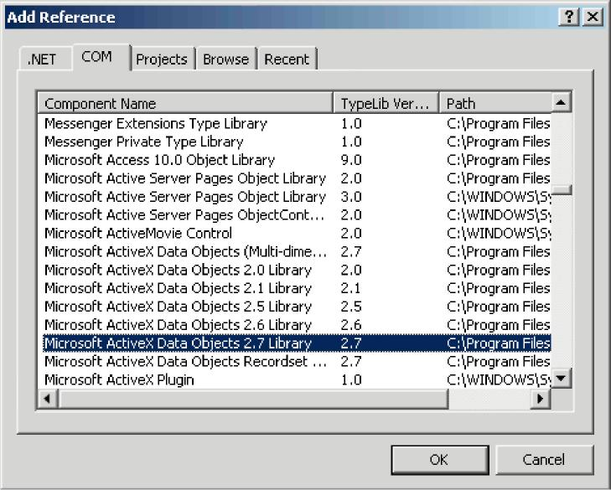
√ Using Type library import tool. Tlbimp.exe yourname.dll.
√ Using interopservices.System.runtime.Interopservices namespace contains class
TypeLib Converter which provides methods to convert COM classes and interface in to assembly metadata.
√ Make your custom wrappe rs.If your COM component does not have type library then the only way to communicate is writing custom wrappers. That means communicating directly with COM components.
(I) Once I have developed the COM wrapper do I have to still register the COM in registry?
Ye s.
(A)How can we use .NET components in COM?
Twist :- What is CCW (COM callable wrapper) ?, What caution needs to be taken in order that .NET components is compatible with COM ?
.NET components can not be used in straight forward way with COM. You will need to create CCW in order that COM components communicate with .NET assemblies. Following are the different approaches to implement it :-√ Explicitly declare interfaces..
Public Interface ICustomer
Property CustomerName() As String
Property CustomerCode() As String
Sub AddCustomer() End Interface Public Class Customer
Implements ICustomer
Private PstrCustomerName As String
Private PstrCustomerCode As String
Public Sub AddCustomer() Implements ICustomer.AddCustomer Try
‘ addin of database code can go here Catch ex As Exception
Throw ex End Try
End Sub
Public Property CustomerCode() As String Implements ICustomer.CustomerCode Get
Return PstrCustomerCode End Get Set(ByVal value As String)
PstrCustomerCode = value End Set End Property
Public Property CustomerName() As String Implements ICustomer.CustomerName Get
Return PstrCustomerName End Get Set(ByVal value As String)
PstrCustomerName = value End Set End Property
Public Sub New()
End Sub End Class
Note :- Source code of this is provided in CD in SOURCECODE folder in COMCALLABLEWRAPPER
The above customer class is going to be used by COM components so all the properties and methods are declared in interface and implemented in the customer class. Customer Name.Customer Code and AddCustomer are first declared in ICustomer and then implemented in Customer Class. Also note that the class must have a default constructor.
Note :- All source code in this book is provided in VB.NET that does not mean that author of the book does not like C#. In fact the main programming language of author is C#. In order to keep things small I have only used one language. But the conversion is so seamless that it is of least matter.
√ The second way to create CCW is by using InteropServices attributes. Here interfaces
are created automatically.
Following are different type of class attributes :
None:-No class interface is generated for the class. This is default setting when you do not specify anything.
AutoDispatch :- Interface that supports IDispatch is created for the class. However, no type information is produced.
AutoDual :- A dual interface is created for the class. Type information is produced and made available in the type library.
Below in the source code we have used the third attribute.
Imports System.Runtime.InteropServices
<ClassInterfaceAttribute(ClassInterfaceType.AutoDual)> _ Public Class ClsCompliant
End Class
Other than class attributes defined up there are other attributes with which you can govern other part of assembly.Example “GuidAttribute” allows you to specify the GUID, “ComVisibleAttribute” can be used to hide .NET types from COM etc. All attributes are not in scope of the book as this is a interview questions book refer MSDN for more details.
√ Once .NET assembly is created using either interface or using interopservices method we need to create a COM type library using Type library export tool.
Tlbexp (AssemblyName)
√ The final thing is registering the CCW in registry using regasm tool.
regasm AssemblyName [Options]
√ Finally refer the TLB in your COM IDE Below is figure showing VB6 IDE referencing the DLL
Note :- DLL and TLB should be in same directory where the application is executed.
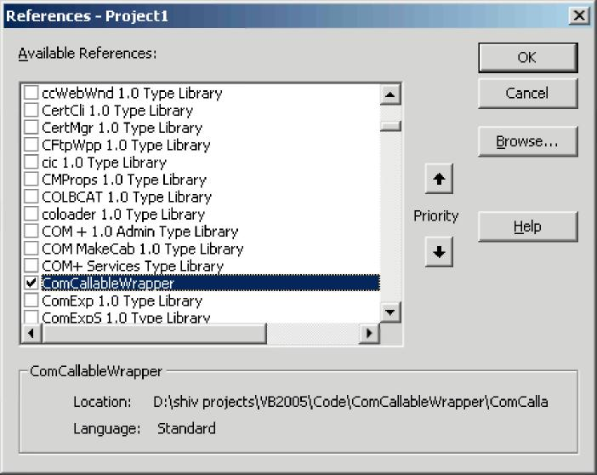
Figure :- 2.2 VB6 IDE referencing the CCW
(A)How can we make Windows API calls in .NET?
Windows API call are not COM based and they are invoked through Platform Invoke Services.
Declare StringConversionType (Function | Sub) MethodName Lib "DllName" ([Args]) As Type
√ StringConversionType is for what type of conversion should take place. Either we
can specify Unicode to convert all strings to Unicode values, or Auto to convert
strings according to the .NET runtime rules.
√ MethodName is the name of the API to call.
√ DllName is the name of the DLL.
√ Args are any arguments to the API call.
√ Type is the return type of the API call. Below is a sample code for VB.NET which uses Sleep windows API for delaying.
Public Class Form1
Declare Auto Sub Sleep Lib “kernel32.dll” (ByVal dwMilliseconds As Long)
Private Sub Form1_Load(ByVal sender As System.Object, ByVal e As System.EventArgs) Handles MyBase.Load
MessageBox.Show(“ start sleeping for 5000 Milli
seconds ”)
Sleep(5000)
MessageBox.Show(“ end of sleeping ”)
End Sub End Class
Note:- Source code is provided in CD in “APICALL” folder
In VB.NET we use declare keyword but in C# it goes little bit different, we use DLLIMPORT here.
Note :- We have interopservices in this and EXTERN keyword.
#region Using directives
using System;
using System.Collections.Generic;
using System.ComponentModel;
using System.Data;
using System.Drawing;
using System.Windows.Forms;
using System.Runtime.InteropServices;
#endregion
namespace CSharpCode {
partial class Form1 : Form {
[DllImport(“Kernel32.dll”)]
static extern int Sleep(long dwMilliseconds);
public Form1()
{
InitializeComponent();
}
private void Form1_Load(object sender, EventArgs e)
{
MessageBox.Show(“Starting of 5000 ms...”); Sleep(5000);
MessageBox.Show(“End of 5000 ms...”); } } }
(B)When we use windows API in .NET is it managed or unmanaged code ?
Windows API in .NET is unmanaged code.
Note:- Even though VB6 and V C++ has gone off still many people do ask these old questions again and again. Still there are decent old application which are working with COM very much fine. So interviewer still asks you these questions so that those application’s can be ported to .NET. So let’s play some old music... By the way my favourite music is Kishore, what’s yours???
(I)What is COM ?
Microsoft’s COM is a technology for component software development. It is a binary standard which is language independent. DCOM is a distributed extension of COM.
(A) What is Reference counting in COM ?
Reference counting is a memory management technique used to count how many times an object has a pointer referring to it. The first time it is created, the reference count is set to one. When the last reference to the object is nulled, the reference count is set to zero and the object is deleted. Care must be exercised to prevent a context switch from changing the reference count at the time of deletion. In the methods that follow, the syntax is shortened to keep the scope of the discussion brief and manageable.
(A) Can you describe IUKNOWN interface in short ?
Every COM object supports at least one interface, the IUnknown interface. All interfaces are classes derived from the base class IUnknown. Each interface supports methods access data and perform operations transparently to the programmer. For example, IUnknown supports three methods, AddRef, Release(), and QueryInterface(). Suppose that pinterf is a pointer to an IUnknown. pinterf->AddRef() increments the reference count. pinterf->Release() decrements the reference count, deleting the object when the reference count reaches zero. pinterf->QueryInterface( IDesired,
pDesired) checks to see if the current interface (IUnknown) supports another interface, IDesired, creates an instance (via a call to CoCreateInstance()) of the object if the reference count is zero (the object does not yet exist), and then calls pDesired->AddRef() to increment the reference count (where pDesired is a pointer to IDesired) and returns the pointer to the caller.
(I)Can you explain what is DCOM ?
DCOM differs from COM in that it allows for creating objects distributed across a network, a protocol for invoking that object’s methods, and secures access to the object. DCOM provides a wrapper around COM, hence it is a backwards compatible extension. DCOM uses Remote Procedural Calls (RPC) using Open Software Foundation’s Distributed Computing Environment.
These RPC are implemented over TCP/IP and named pipes. The protocol which is actually being used is registered just prior to use, as opposed to being registered at initialization time. The reason for this is that if a protocol is not being used, it will not be loaded.
In order to inform an object that the client is still alive, periodic pinging is used. Hence, when the client has died and no ping has been received (to refresh it) before the expiration time, the server object will perform some clean up tasks (including decrementing its reference count).
Since RPC across a network are typically slow (compared to processes residing on the same machine), DCOM sends multiple requests in the same call. For example, in COM, the program performs a QueryInterface, one interface at a time. In DCOM, multiple QueryInterfaces are all clustered into one call.
This clustering optimization trick is also used when creating an instance of the object and serializing it with data. Since these two operations usually occur together, DCOM allows one method which will perform both operations in one call without waiting for an acknowledgment from the first task before performing the second one.
Similarly, when a client pings its server object, he can do it in one call. Moreover, if there are multiple clients sending pings to multiple servers, an optimization is made where the multiple pings going to the same object are consolidated into just one ping. This is to cut down on the use of precious bandwidth used only for pinging.
The client has the control to set the computer which will be responsible for the lifetime of the object. That is to say, these objects are not created just somewhere where the system resources and access privileges allow for it.
Call security is implemented in all four ways: authentication (to prevent false clients from impersonating the true client), authorization (to insure that a client only does what it is authorized to do), data integrity (to insure that data was not tampered with during transit) and data privacy (to insure that only designated sources can read it). The security issues are handled as they are on
operating systems. The client gives the server various access privileges to access memory or disk space
(B)How do we create DCOM object in VB6?
Using the CreateObject method you can create a DCOM object. You have to put the server name in the registry.
(A)How to implement DTC in .NET ?
DTC is implemented using COM+. Following are the steps to implement COM + in .NET :-√ “EnterpriseService” namespace has all the classes by which we can implement DTC in .NET. You have to add reference “EnterpriseService” namespace.
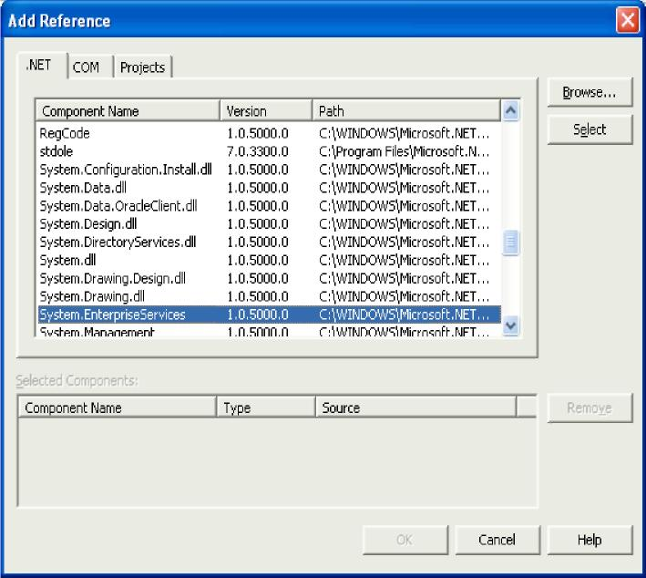
Figure :- 2.3 Add reference to EnterpriseServices.
√ You class must derive from “Serviced Component” object.
√ Then you have to define your class with the transaction attribute
(For all transaction attribute look the down question)
[ Transaction(TransactionOption.RequiresNew) ]
√ After the class level transaction type is defined. Its time to define at the method level the AutoComplete attribute. Autocomplete attribute says that if no exception is thrown then mark its part of the transaction as being okay. This helps cut down on the amount of code required. If the implementation sets AutoComplete to false, or
omits it all together, then we would need to manage the transaction manually. To manually control the transaction you will need to use the ContextUtil class and its static members. Following is small snippet of ContextUtil: -
public void SampleFunction()
{
try
{
// Do something to a database
// ...
// Everything okay so far Commit the transaction
ContextUtil.SetComplete(); }
catch(Exception) {
// Something went wrong Abort and Rollback the Transaction.
ContextUtil.SetAbort();
}
}
√ Component derived from “ServicedComponent” should be strong named as they run under COM+.
√ Once the classes are compiled using the string name.Register the Component in COM+ services using
regsvcs c:\DllPath\TransactionComponent.dll
√ You can see that the component is registered using the COM+ explorer.
(A)How many types of Transactions are there in COM + .NET ?
There are 5 transactions types that can be used with COM+. Whenever an object is registered with COM+ it has to abide either to these 5 transaction types.
Disabled: - There is no transaction. COM+ does not provide transaction support for this component.
Not Supported: - Component does not support transactions. Hence even if the calling component in the hierarchy is transaction enabled this component will not participate in the transaction.
Supported: - Components with transaction type support will be a part of the transaction. This will be only if the calling component has an active transaction. If the calling component is not transaction enabled this component will not start a new transaction.
Required: - Components with this attribute require a transaction i.e. either the calling should have a transaction in place else this component will start a new transaction.
Required New: - Components enabled with this transaction type always require a new transaction. Components with required new transaction type instantiate a new transaction for themselves every time.
(A)How do you do object pooling in .NET ?
COM+ reduces overhead by creating object from scratch. So in COM+ when object is activated its activated from pool and when its deactivated it’s pushed back to the pool. Object pooling is configures by using the “ObjectPoolingAttribute” to the class.
Note:- When a class is marked with objectpooling attribute it can not be inherited.
ObjectPooling(MinPoolSize := 2, MaxPoolSize := 5, CreationTimeout := 20000)> _
Public Class testingclass
Inherits ServicedComponent
Public Sub DoWork()
' Method contents go here.
End Sub
End Class
Above is a sample code which has the “ObjectPooling” attribute defined. Below is a sample code which uses the class.
Public Class App
Overloads Public Shared Sub Main(args() As String)
Dim xyz As New TestObjectPooling()
xyz.doWork()
ServicedComponent.DisposeObject (xyz)
End Sub
End Class
Above is a sample code which uses the object pooled object. Note the DisposeObject() This ensures its safe return to the object pool.
(A)What are types of compatibility in VB6?
There are three possible project compatibility settings: √ No Compatibility √ Project Compatibility √ Binary Compatibility
No Compatibility
With this setting, new class ID’s, new interface ID’s and a new type library ID will be generated by VB each time the ActiveX component project is compiled. This will cause any compiled client components to fail (with error 429!) and report a missing reference to the 'VB ActiveX Test Component' when a client project is loaded in the VB IDE.
Note :- Use this setting to compile the initial release of a component to other developers.
Project Compatibility
With this setting, VB will generate new interface ID’s for classes whose interfaces have changed, but will not change the class ID’s or the type library ID. This will still cause any compiled client components to fail (with error 429!) but will not report a missing reference to the 'VB ActiveX Test Component' when a client project is loaded in the VB IDE. Recompilation of client components will restore them to working order again.
Note:- Use this setting during the initial development and testing of a component within the IDE and before the component is released to other developers.
Binary Compatibility
VB makes it possible to extend an existing class or interface by adding new methods and properties etc. and yet still retain binary compatibility. It can do this, because it silently creates a new interface ID for the extended interface and adds registration code to register the original interface ID but with a new Forward key containing the value of this new interface ID. COM will then substitute calls having the old ID with the new ID and hence applications built against the old interface will continue to work (assuming the inner workings of the component remain backward compatible!).
With this setting, VB will not change any of the existing class, interface or type library ID’s, however in order that it can do so, VB requires the project to specify an existing compiled version that it can compare against to ensure that existing interfaces have not been broken
(A)What is equivalent for regsvr32 exe in .NET ?
Regasm

